# Raspberry Pi RetroPie

Written by Mark Webster

***Summary***: Learn to install the retro game simulator RetroPie and download games

## Introduction

The single board computer Raspberry Pi 3 has more power than the specialized gaming machines from the 1970’s, 1980’s, and even many from the 1990’s. The Raspberry Pi can run emulators that allow old games written for other computers to run on the Raspberry Pi. This means simulating the CPU, GPU, and the input controllers. The specialized operating system dedicated to old computer games is called RetroPie.

Many old games (called ROMs) have been made public domain or free to use. There are many locations online to download these games.

The official website for RetroPie is: <https://retropie.org.uk/>

Currently supported gaming consoles include:

Playstation 1, Playstation 2, SEGA, SNES, Wii, Nintendo NES, Game Boy, Commodore 64, Atari, Amiga, and at least 100 others.

## Hardware

Although RetroPie will work on older versions of the Raspberry Pi, it is recommended to use the latest and most powerful processor, currently the Raspberry Pi 3b+

Cases

Controllers

Keyboard

RetroPie software is called EmulationStation which can also be run under Ubuntu Linux or Ubuntu derivatives like Ubuntu Mate.

## Installation

There is a well done installation guide for first time users of RetroPie

<https://retropie.org.uk/docs/First-Installation/>

RetroPie is usually installed as an SD card image, the same as making a bootable SD card for Raspbian.

On the RetroPie website go to <https://retropie.org.uk/download/>

Click on the download link for the version of Raspberry Pi hardware.

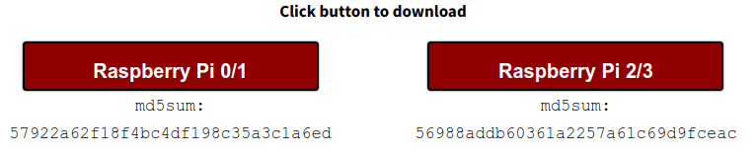

After downloading and decompressing (extracting) the *.img file, use a tool to copy the file to the SD card. A cross platform program is Etcher at <https://www.balena.io/etcher/>

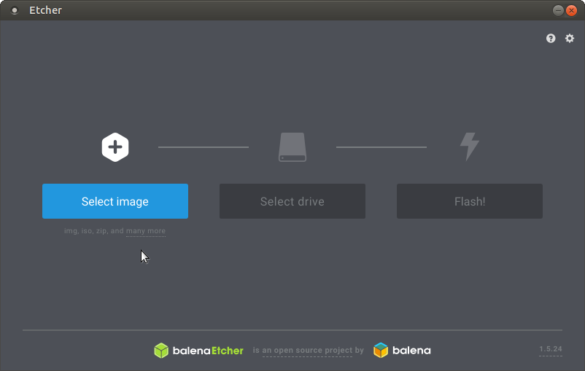

### Exercise 1: Make a bootable SD card

From an image file such as retropie-4.4-rpi2_rpi3.img, use the Etcher software to create a bootable SD card.

Put the SD card into the Raspberry Pi computer and boot. The first time it executes it will ask to configure the controller or keyboard used.

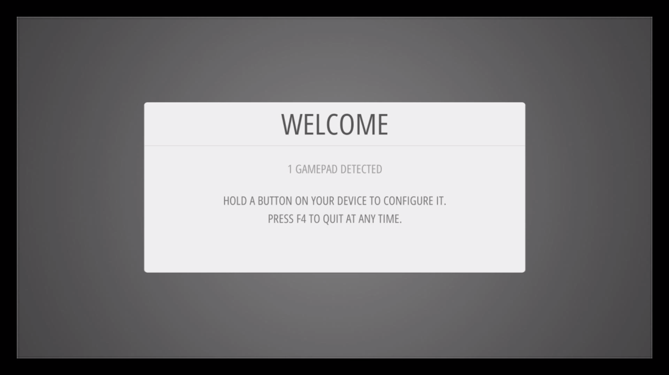

Multiple controllers can be configured.

Which game machine emulators show up will depend on which game ROMs are installed on the Raspberry Pi.

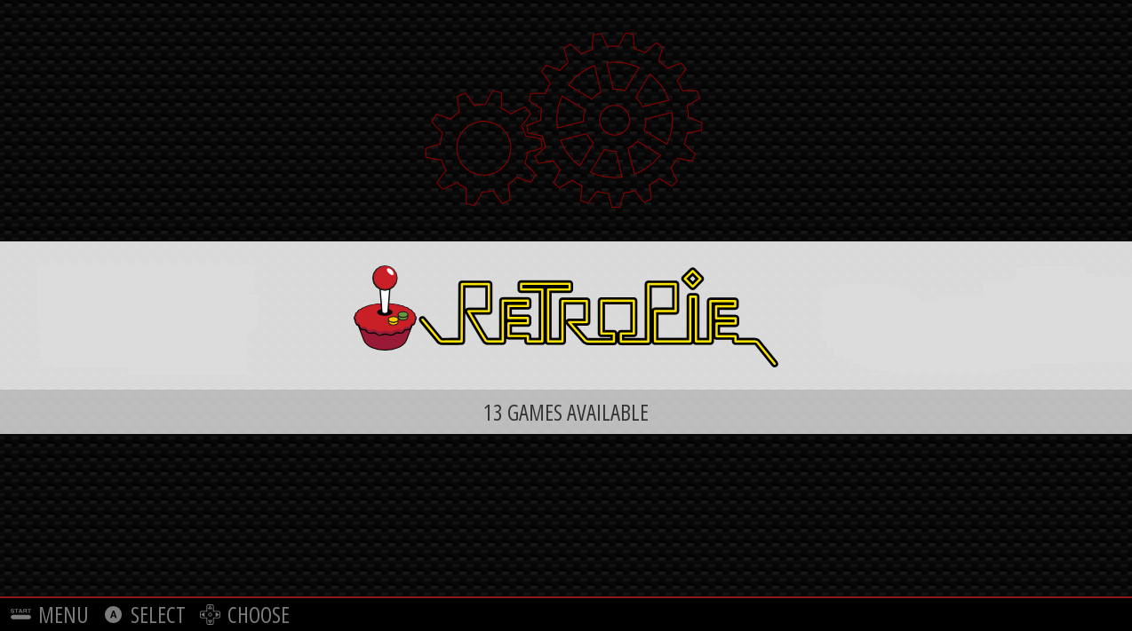

To manually install on top of an existing Raspbian system see the directions at: [https://retropie.org.uk/docs/Manual-Installation/https://retropie.org.uk/docs/Manual-Installation/](https://retropie.org.uk/docs/Manual-Installation/)

If manually installing, first use raspi-config to increase the amount of graphics memory GPU allocated since games are very graphics intensive.

### Exercise 2: Launch and play a game

## Download ROMS

Game ROMs can be transferred into RetroPie using either from the Internet using Wifi or an ethernet cable, or can be copied using a USB flash drive from another computer. The ROMs must be placed in the appropriate game console folder. When using a USB flash drive, create a folder called “retropie/roms” with subfolders for the specific game machine.

A description of how to transfer ROM files can be found at:

<https://github.com/RetroPie/RetroPie-Setup/wiki/Transferring-Roms>

There is a YouTube video on how to copy ROMS over on a USB drive.

<https://www.youtube.com/watch?v=OYMoxvbkYD4>

Files can also be transferred using Wifi, SSH , SFTP or even SAMBA-Shares.

After transfering new ROMs, restart the emulationstation software.

Public domain

Legal

Pirated

To find ROM packs just search for “Retropie ROM”

Online sources of ROM packs include:

Free games:

<https://www.mamedev.org/roms/>

Many games of various copyright status:

<https://www.arcadepunks.com/download-rom-sets-roms-romsets-arcade-console-emulation/>

A simple Internet search for “retropie roms” will provide links to thousands of downloadable ROM files. Unfortunately most of these files are of questionable legal status.

A semi-legal site is “archive.org” where search for “game rom” will bring up thousands of entries. Various legal challenges are agreements have defined archive.org as a library where users can check out files to explore.

### Exercise 3: Copy a ROM using a USB drive

Download a legal ROM file or use one provided by the workshop instructor. Copy it into the appropriate folder inside the “retropie/rom” folder on the USB drive.

If the USB hasn’t been formated, then create a folder called “retropie” on the USB drive. Then put the USB into a port on the Raspberry Pi running the retropie software. Wait while the retropie system creates all the game emulator subdirectories on the USB drive. Them move the USB to another computer connected to the Internet and copy some ROM files into the appropriate emulator folder on the USB. Eject the USB and move it back to the Raspberry Pi running the retropie software. It will copy the files onto the system SD card. On reboot, the raspberry pi will recognize the new games.

To find out the subdirectory name for a particular game machine emulator, go to the list of emulators at: <https://github.com/RetroPie/RetroPie-Setup/wiki/Supported-Systems>

Then for the particular game system name, go to the emulator page in github and look for a retropie/rom/ folder name. For example, for the Nintendo GameCube, go to the GameCube emulator and scroll down to where it says “Place your GameCube ROMs in” and then it lists the subdirectory “/home/pi/RetroPie/roms/gc”